Beacon Yun IoT Service Dashboard User Guide

# Summary

Beacon Yun IoT Service is a platform for demonstrating with the Thingoo G1 BLE Gateway, which currently supports the use of the G1 gateway to view data acquisition data from iBeacon, S1 sensors and custom BLE devices.

The purpose of this guide is to help user learn more about each features of BeaconYun IoT Service.

BeaconYun IoT Service link： <http://iot.beaconyun.com>

# Quick Start

Only need 2 steps can quick start Beacon Yun IoT Service.

1. Open <http://iot.beaconyun.com>，Register and login.
2. In the gateway management, add the gateway information, MAC address for the use of the Thingoo G1 BLE gateway MAC address.
3. In the device management, add the device information, the type of "iBeacon", "Sensor", "Unknown", MAC address for the corresponding type of device.

Note: You can only see the gateway information you added and the BLE device data they collected.

# Login

Registered users use the mailbox and password to log in. New users please click Sign up to register.

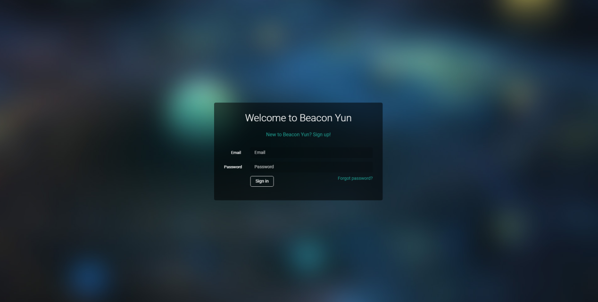

# Register

New users can use the mailbox to register, please be sure to fill in a valid mailbox, otherwise it may lead to forget the password can not be recovered.

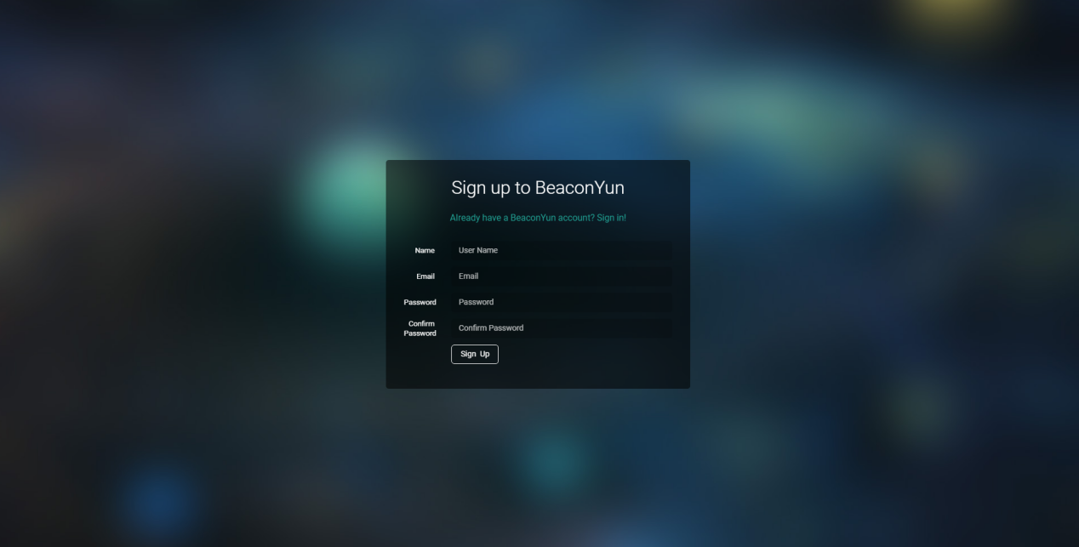

# Dashboard

After logging in to the console, the default interface is the control panel that displays the overview data. You can view the number of added devices, the number of added gateways, the number of servers and the number of messages, and the information about the gateway and device.

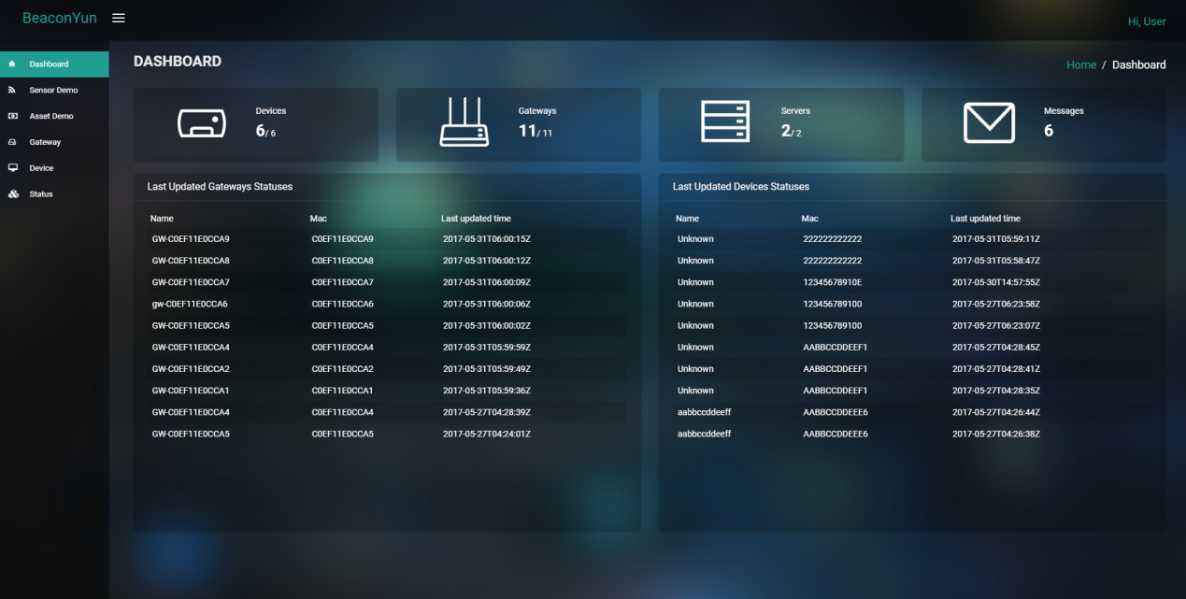

# Gateway Management

Through the gateway management, you can create gateway, edit the gateway name. Once you have added the gateway, you can see the data for the gateway being added to the console.

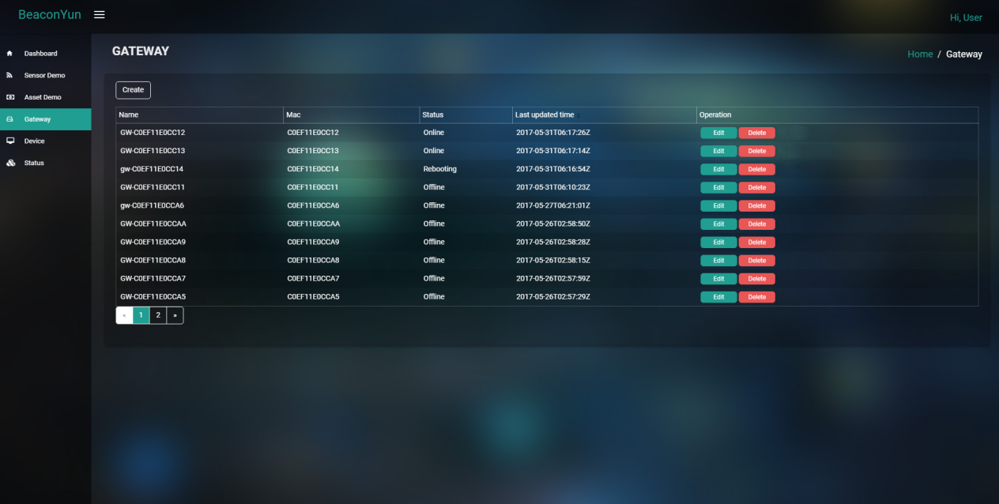

## Create Gateway

When creating a gateway, the MAC address is used for the Thingoo G1 BLE gateway's MAC address, Name and description are unlimited.

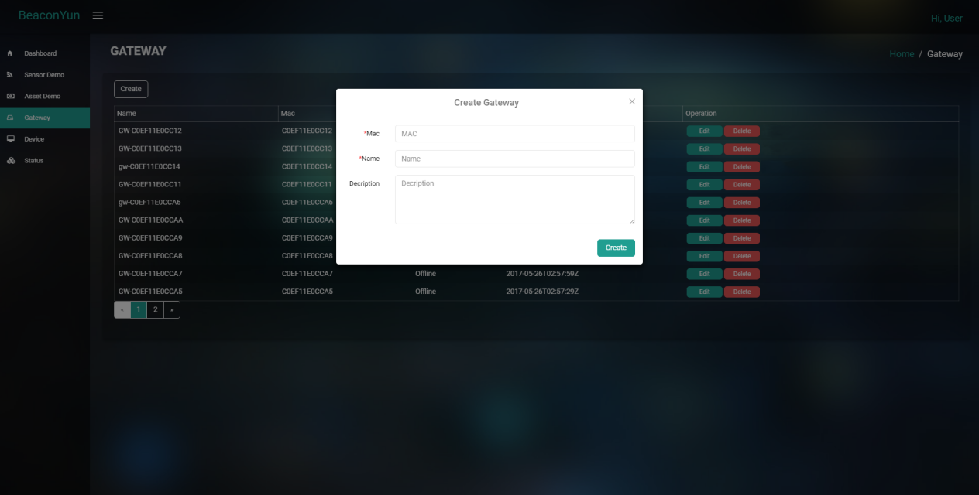

## Edit Gateway

When editing a gateway, the MAC address can not be edited, and the Name and description are unlimited.

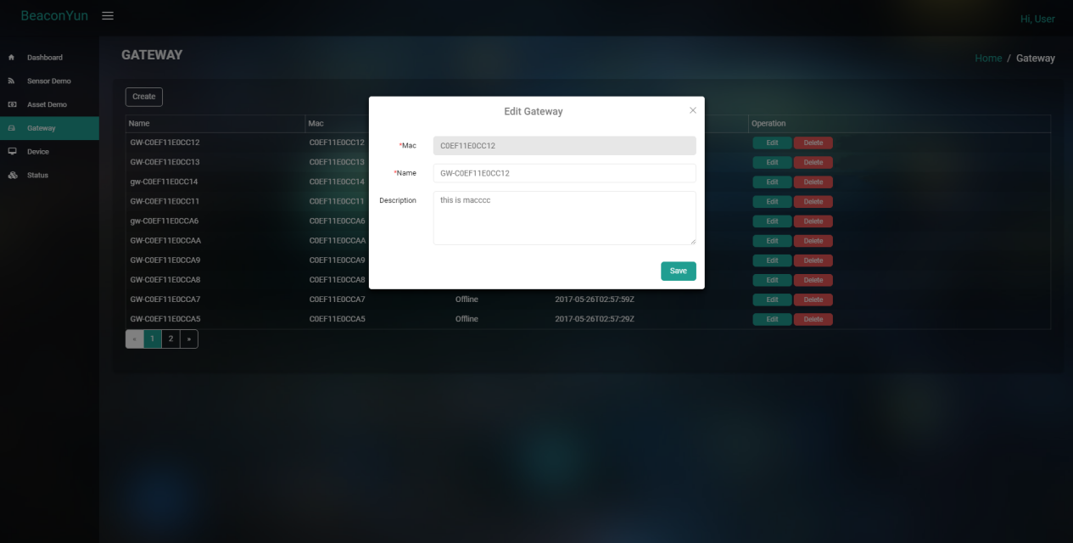

## Delete Gateway

Click delete button and confirm to delete the gateway.

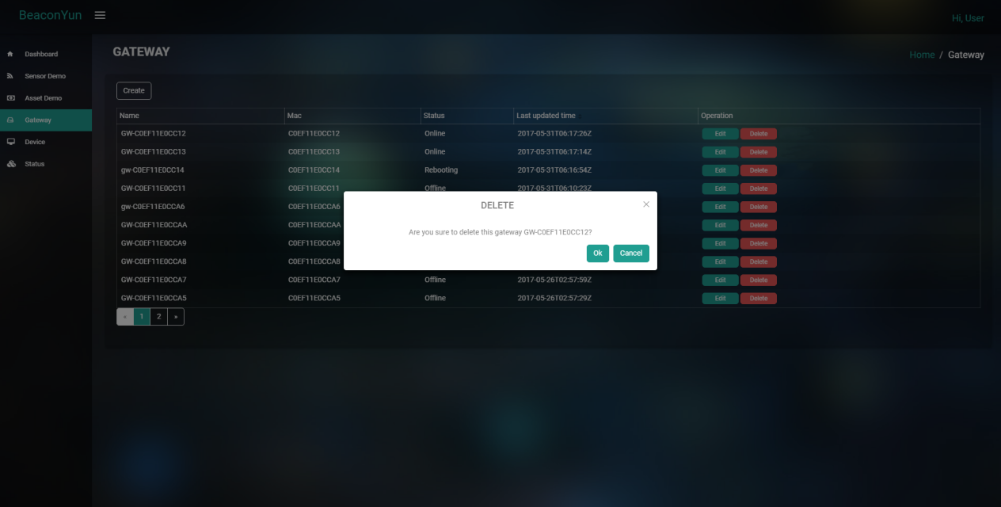

# Device Management

With Device Management, you can create device, edit device name, and view the last active time of your device. When you create device, you can see the data of the device you added on the console. The name of the device that was not added is displayed as "Unknown".

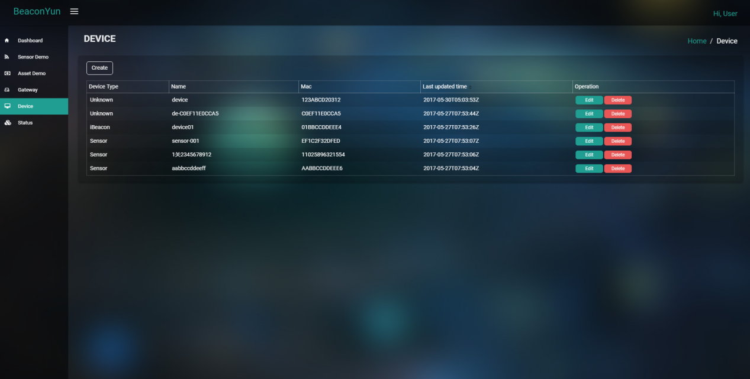

## Create Device

When creating a device, the MAC address is the MAC address of the device. The device type is "iBeacon", "Sensor", "Unknown", Name and description are unlimited.

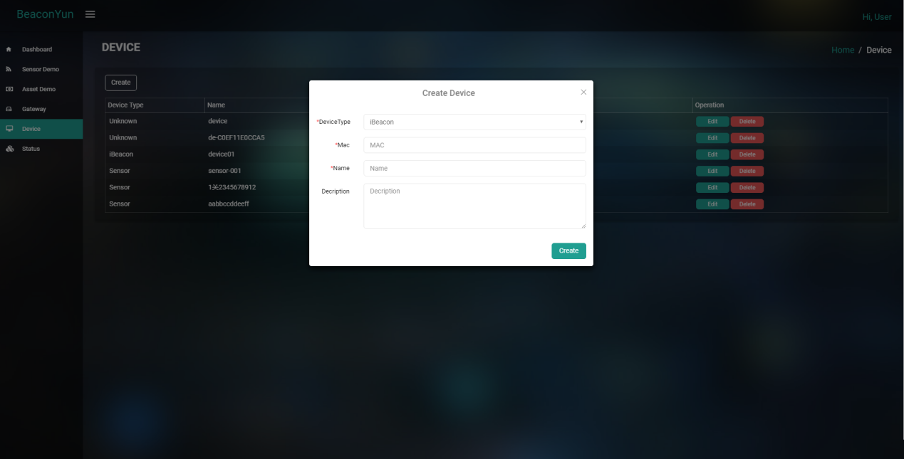

## Edit Device

When editing a device, the MAC address can not be edited, the device type can not be edited, the Name and description are unlimited.

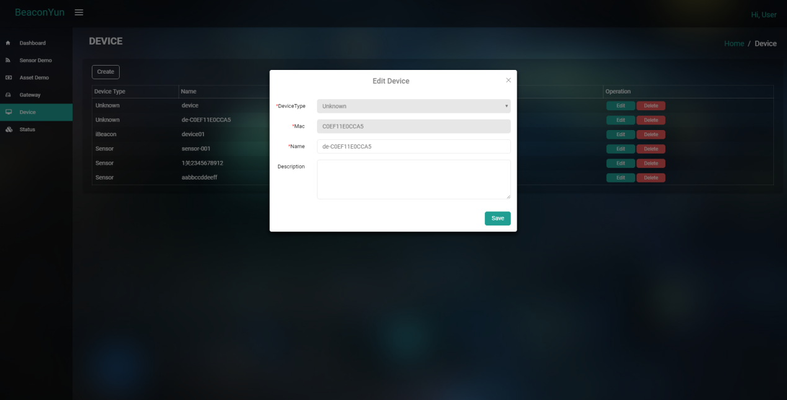

## Delete Device

Click delete button and confirm to delete the device.

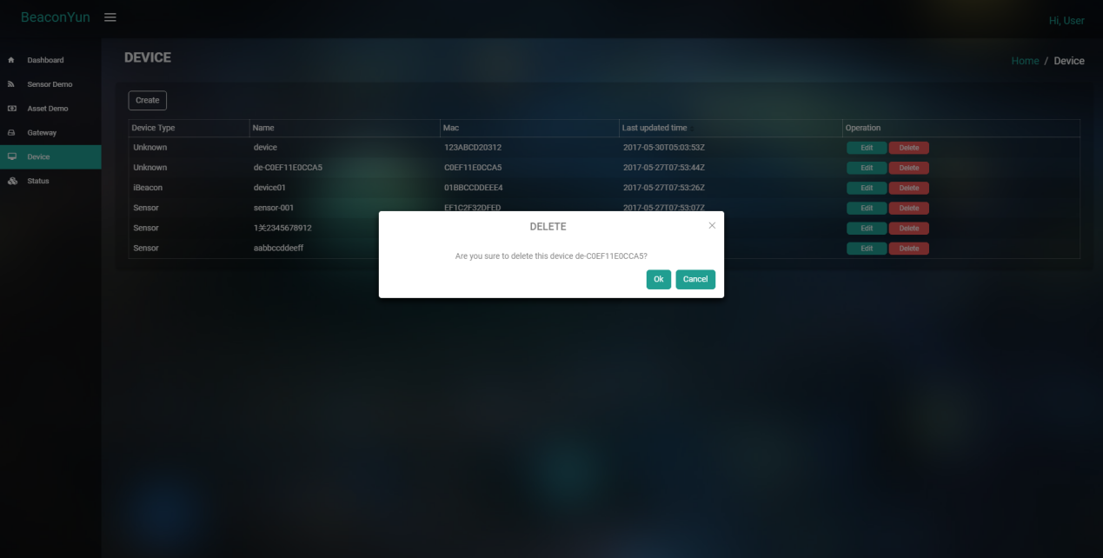

# Status

In the device management, all the users to add the gateway to collect the device status will be in this list.

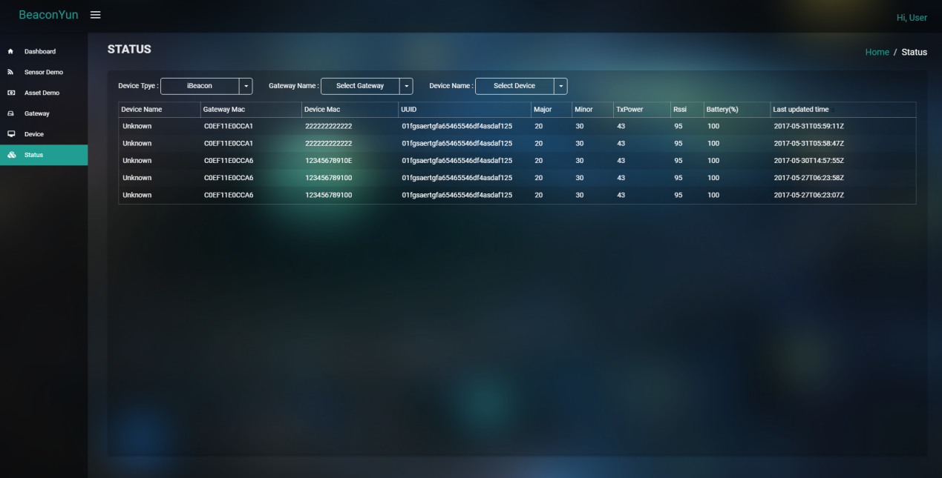

The device status can be filtered according to the device type, gateway MAC, and device MAC. You can use a variety of combinations to view the current state of the device, such as the sensor data under the same gateway, or the same iBeacon device on multiple gateways.

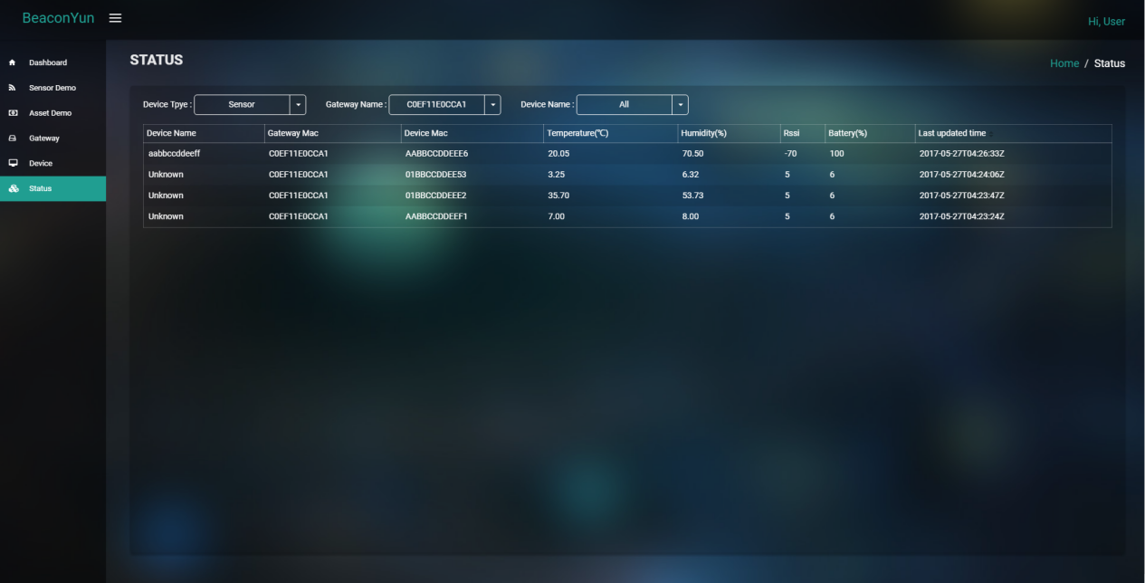

# Sensor Demo

The sensor presentation interface provides the graphical representation of the sensor data collected by the online gateway.

Using the online gateway and online sensor list, you can select the sensor of interest and use the graph to view the current status and historical trends of the sensor data.

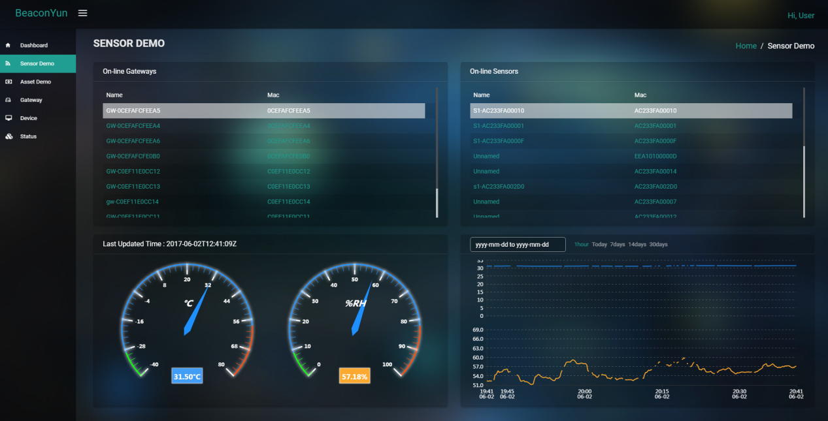

# Asset Demo

The asset management interface provides an asset management demonstration based on iBeacon data. You can select the gateway that you are interested in, and when the number of iBeacons received by the concerned gateway increases or decreases, it will be displayed dynamically on the corresponding device list and floor plan.

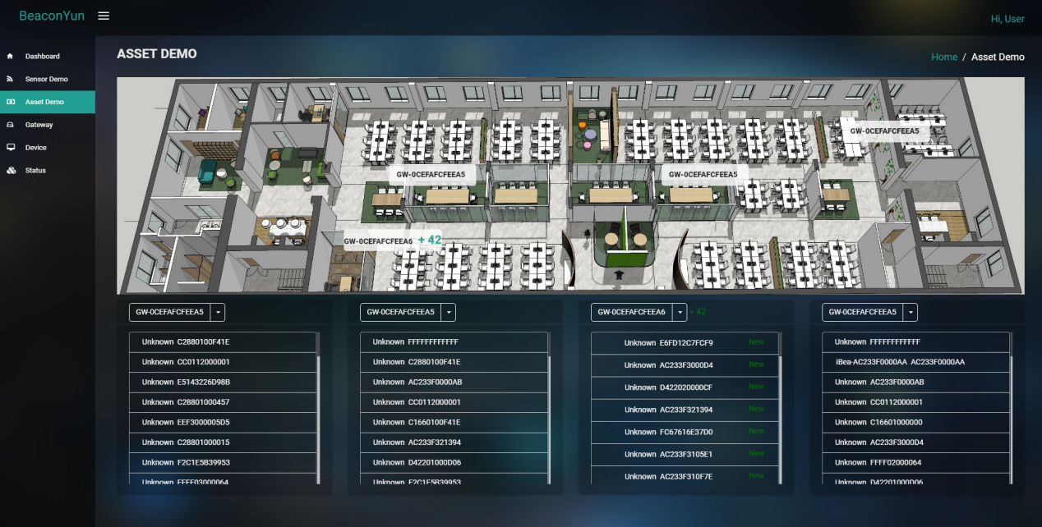

# Profile

In the profile, you can edit the nickname, change the password, can not edit the mailbox.

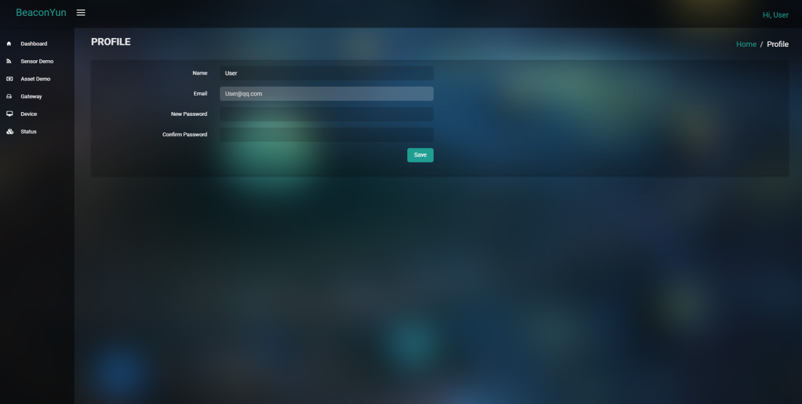

# Sign out

Click on the top right corner of the nickname, in the pop-up menu, choose to sign out, you can log out.

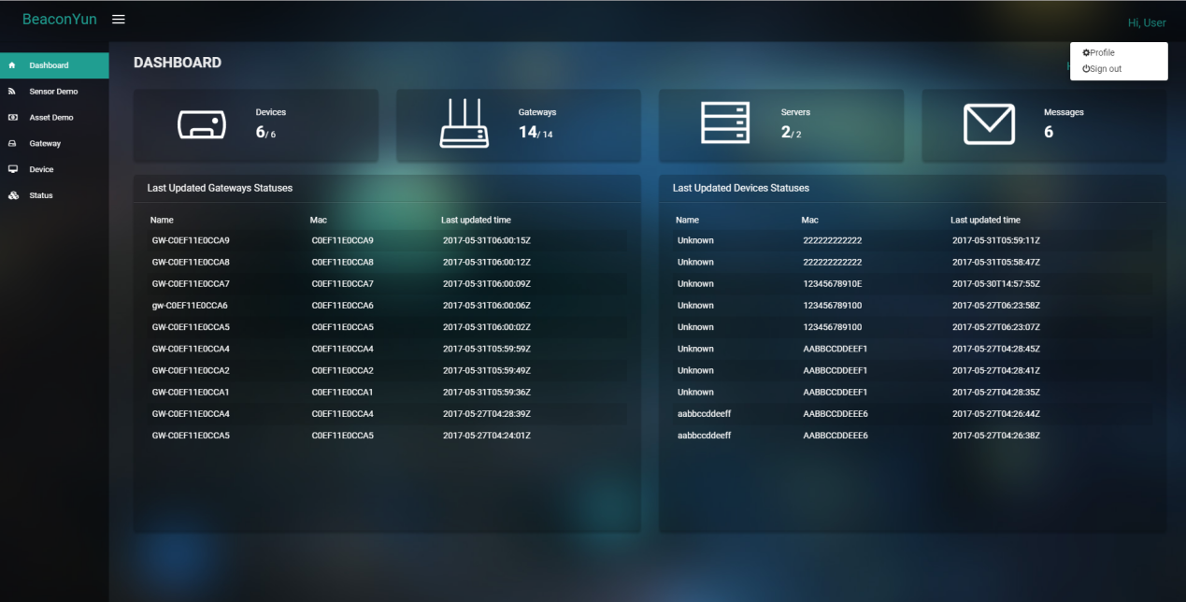

# User management

User management provides the user to create, edit, delete and view the sub-user gateway list, only the administrator has user management.

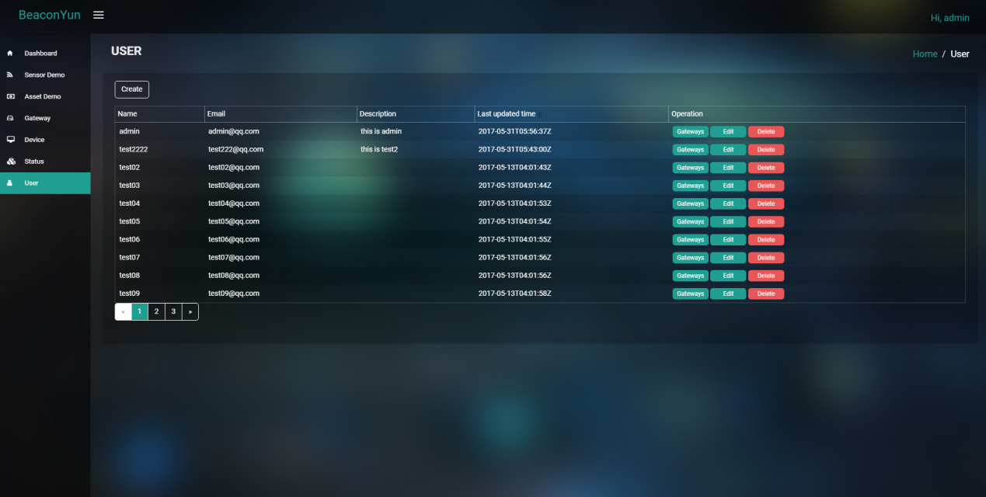

## Create user

Create the user, you need to fill out the mailbox, user name and password.

Please be sure to fill in a valid mailbox, otherwise it may cause the user to forget the password can not be recovered.

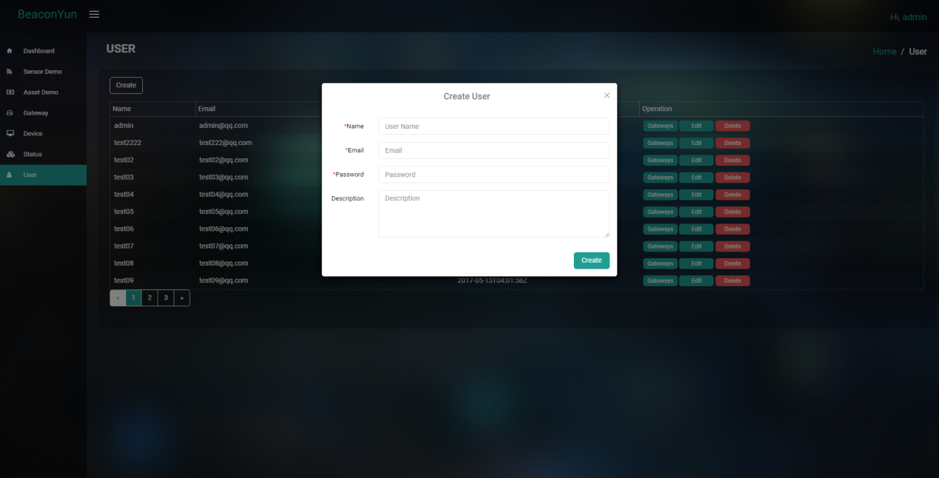

## Edit user

Edit the user, the mailbox can not be edited, leave the password is not edit password.

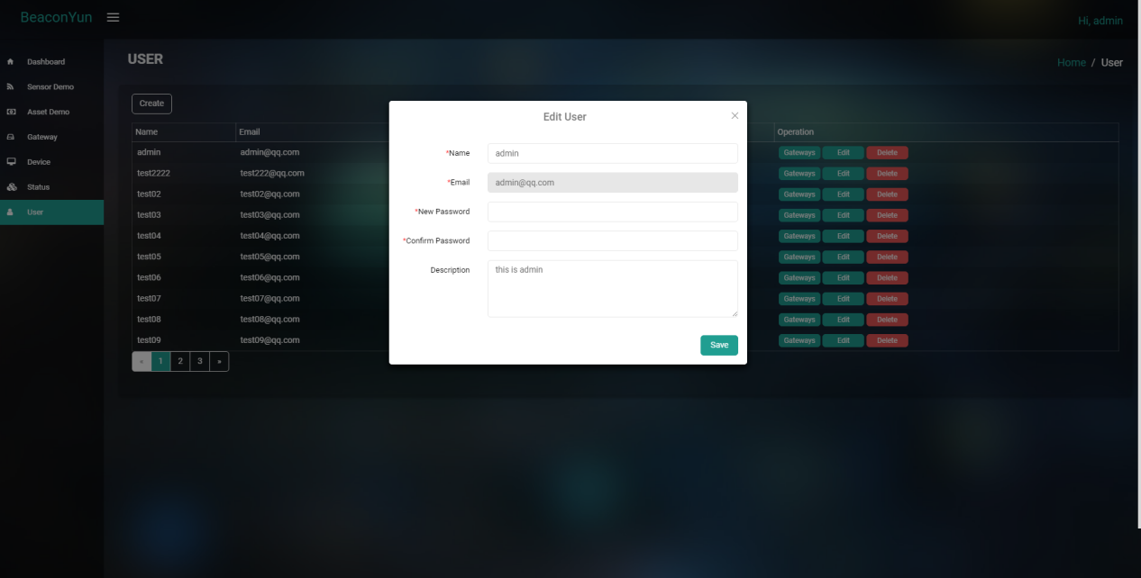

## Delete user

Click delete button and confirm to delete the user.

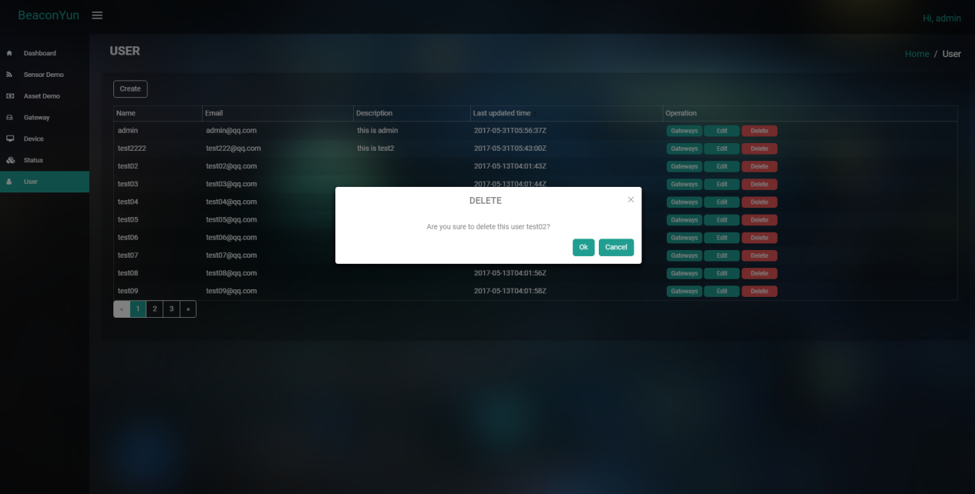

## The List Of All Sub-users’ Gateways

The administrator can view the list of all sub-users' gateways.

